Table of Contents
1. Introduction 3
1.1 Overview of the KNN and Naïve Bayes Algorithms 3
1.2 Dataset Description and Research Objective 3
2.Perform Exploratory Data Analysis (EDA) 3
2.1 Class Distribution 4
2.2 Check for any missing values, duplicates, and outliers 5
2.3 Class Distribution 6
2.4. Feature Selection and Class-wise Analysis 6
2.5 Data Preprocessing 10
3. Model Building and Evaluation 10
3.1 Naïve Bayes (GaussianNB) Classifier 11
3.2.1 Independence Assumption of Naïve Bayes 11
3.2.2 Model Performance and Evaluation 11
3.2.3 Summary and Interpretation 13
3.3 K-Nearest Neighbors (KNN) Classifier 13
3.3.1 Model Training and Test Evaluation using k=7 13
3.3.3 Visualization of Decision Boundary (Top 2 Features) 16
3.3.4 Summary and Interpretation (KNN) 17
3.4 Model Comparison 17
4. Exploring Artificial Neural Networks (ANN) 20
4.1 Activation Function and Learning Rate in MLP 20
4.2 Baseline Model with MLP Classifier 20
4.3 Tracking Loss Value 21
4.4 Experimenting with Two Hidden Layers 23
4.5 Explaining Accuracy Variation 24
4.6 Comparing MLP Classifier Performance 24

List of Tables

Table 1 Overview of the Parkinson’s Speech Dataset 4
Table 2. Missing Values, Duplicates, and Outlier Summary 5
Table 3 Correlation Matrix of Final Selected Features 7
Table 4 Classification Report for Naïve Bayes Classifier(Train-Test Split) 11
Table 5 Classification Report for Naïve Bayes Classifier(Train-Test Split) 14
Table 6 Performance Comparison of Naïve Bayes and KNN Classifiers 18
Table 7.Accuracy by Number of Neurons (k) 20
Table 8 Final Baseline Results (MLP with 5 Neurons) 21
Table 9 Final Training Loss and Validation Accuracy per Fold 22
Table 10 . Classification Accuracy for Two-Layer Architectures 23
Table 11. Classification Report for MLP Classifier (10-fold CV) 24
Table 12. Performance Comparison of Classifiers 25

List of Figures

Figure 1. Distribution of the Target Variable (class) 6
Figure 2 Correlation Heatmap of Selected Features 8
Figure 3. Boxplots of Five Domain-Relevant Acoustic Features by Class 9
Figure 4 Confusion Matrix for Naïve Bayes Classifier 12
Figure 5 Train vs Test Accuracy by k (KNN) 14
Figure 6 Confusion Matrix for KNN Classifier (k=7) 15
Figure 7 Decision boundary visualization using the top two features 16
Figure 8 Training Loss Curve for Each Fold (MLP with 5 Neurons) 21
Figure 9 Confusion Matrix of MLP Classifier (10-fold CV) 25

Part A

1. Introduction

1.1 Overview of the KNN and Naïve Bayes Algorithms
This report applies two commonly used classification algorithms—K-Nearest Neighbors (KNN) and Naïve Bayes (NB)—to identify individuals with Parkinson’s Disease (PD) based on vocal signal features. KNN is a distance-based algorithm that classifies a data point according to the majority class among its nearest neighbors. Naïve Bayes, on the other hand, is a probabilistic classifier that uses Bayes’ Theorem, assuming conditional independence among features. These two algorithms differ in their decision-making approach and complexity, making them useful for comparative evaluation in biomedical classification tasks.

1.2 Dataset Description and Research Objective
Parkinson’s Disease is a progressive neurodegenerative condition affecting millions of people worldwide. Vocal impairment is one of the earliest symptoms, observed in nearly 90% of PD patients. As a result, voice-based analysis offers a promising, non-invasive method for early diagnosis and telemonitoring of the disease. The dataset used in this study was developed by Sakar et al. (2018) and made available through the UCI Machine Learning Repository (https://doi.org/10.24432/C5MS4X). It includes 754 features extracted from sustained vowel phonation recordings of 252 individuals, consisting of 188 patients diagnosed with PD and 64 healthy controls. These features are derived from various signal processing techniques and include classical acoustic features (e.g., jitter, shimmer), Mel-frequency cepstral coefficients (MFCCs), and tunable Q-factor wavelet transform (TQWT) coefficients.
The primary goal of this project is to classify each voice sample as either Parkinson’s-positive or healthy using supervised learning methods. We aim to evaluate and compare the performance of the KNN and Naïve Bayes classifiers in terms of their predictive accuracy, interpretability, and suitability for clinical applications. This task is important not only for academic exploration but also for its potential impact on the development of practical, scalable diagnostic tools.
In conducting this analysis, we assume that each voice recording is an independent and randomly sampled observation from the target population. We also acknowledge the conditional independence assumption required for the Naïve Bayes classifier, although this may be partially violated due to potential correlations between acoustic features.

2.Perform Exploratory Data Analysis (EDA)

To understand the structure and characteristics of the dataset, exploratory data analysis (EDA) was performed.
To understand the structure and characteristics of the dataset, exploratory data analysis (EDA) was conducted. The dataset initially contained 756 rows; however, the first row was removed during preprocessing because it duplicated the column headers. The resulting dataset includes 755 rows and 755 columns, where each row corresponds to a voice recording. Among the columns, 754 represent acoustic features, and one column (class) serves as the target variable. The class variable indicates whether the speaker has Parkinson’s Disease (1) or is healthy (0).

2.1 Class Distribution

Table 1 Overview of the Parkinson’s Speech Dataset
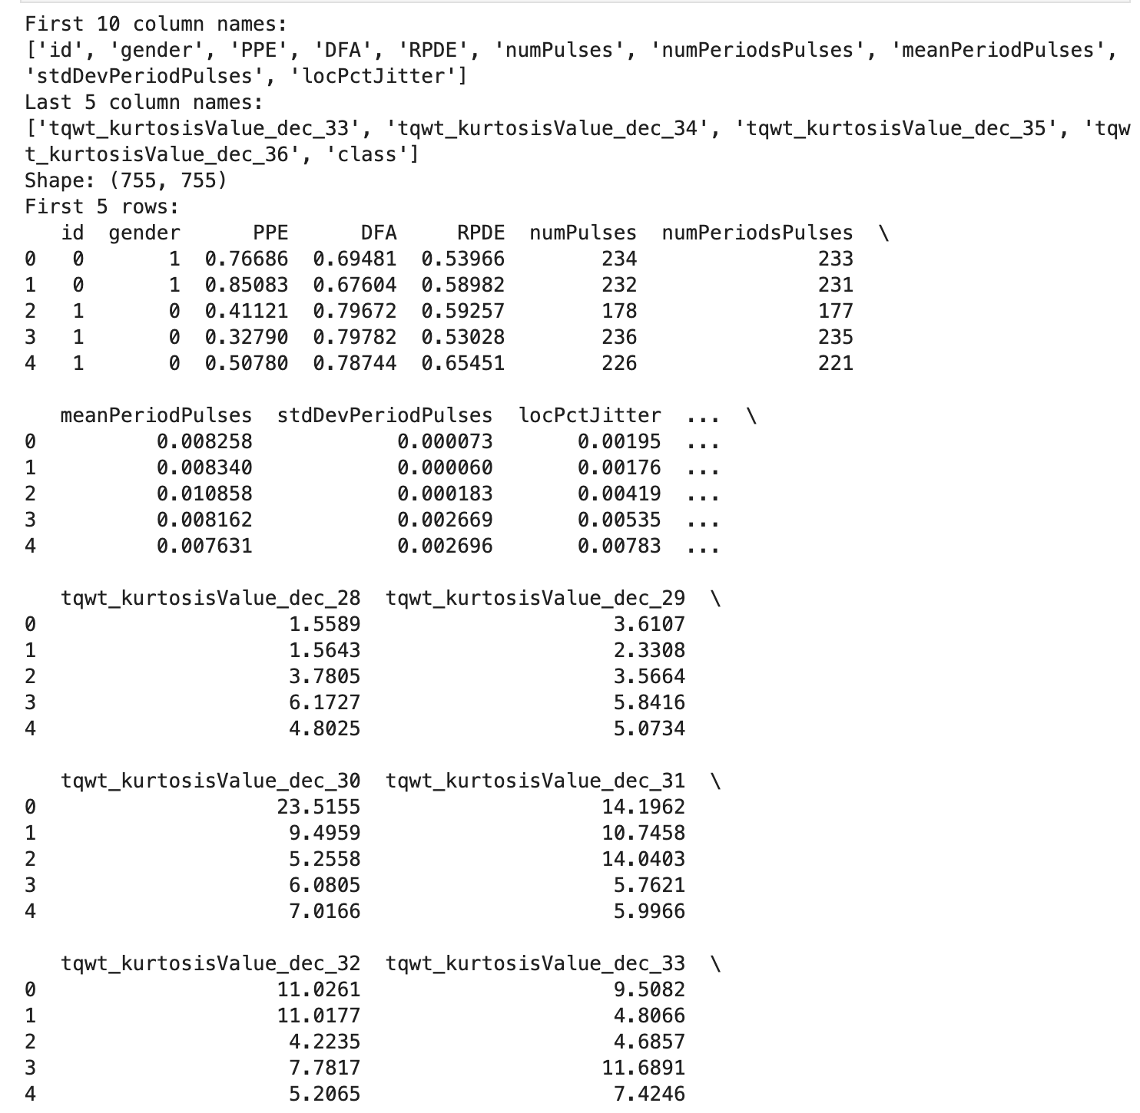
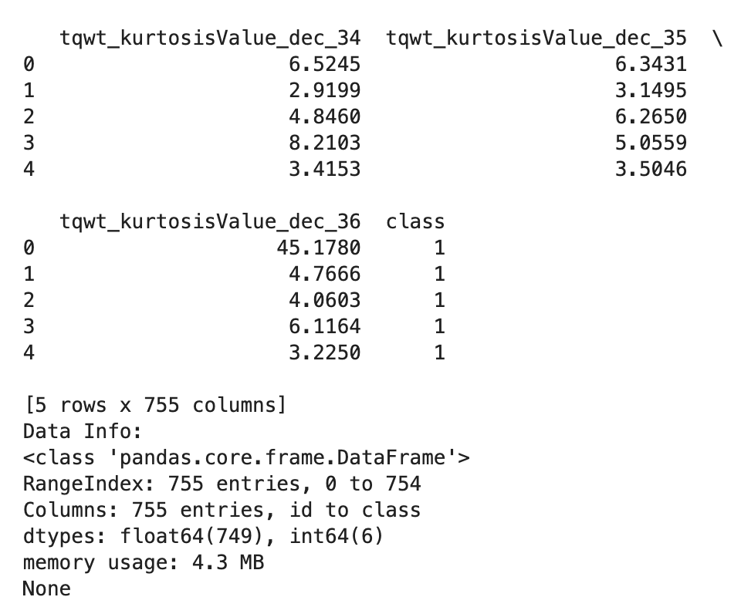

Among the 755 samples, 188 (24.9%) are healthy and 567 (75.1%) have Parkinson’s Disease, indicating a moderate class imbalance.
This imbalance may influence the performance of certain classification models, especially those sensitive to skewed class distributions.

2.2 Check for any missing values, duplicates, and outliers

Table 2. Missing Values, Duplicates, and Outlier Summary
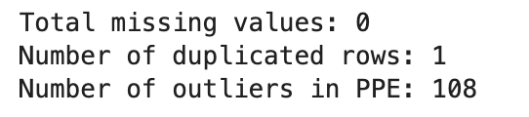

The dataset contained no missing values.
One duplicated row was found and removed.
108 potential outliers were identified in the PPE feature using the IQR method. These values were retained, as they may represent real-world variability relevant to Parkinson’s diagnosis.

2.3 Class Distribution

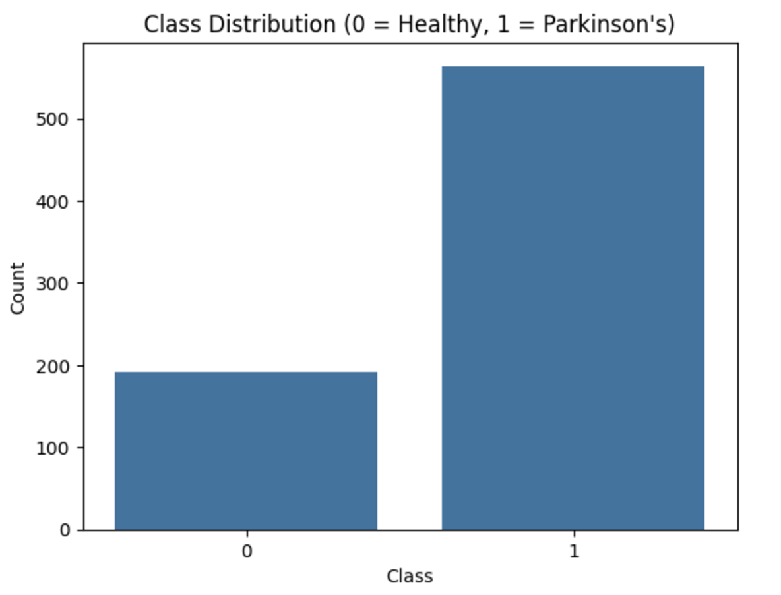

Figure 1. Distribution of the Target Variable (class)

The dataset contains a total of 755 voice recordings, classified as either Parkinson’s-positive (1) or healthy (0).
As shown in Figure 1, there are 567 samples labeled as Parkinson’s Disease and 188 as healthy controls.
This indicates a moderate class imbalance, which should be considered during model evaluation.

2.4. Feature Selection and Class-wise Analysis

In this section, five features were selected using an ANOVA F-test–based feature selection method, which evaluates the statistical significance of each feature in distinguishing between healthy individuals and those with Parkinson’s Disease. From the top-ranked features, highly correlated variables (with a correlation coefficient greater than 0.7) were removed to avoid redundancy. As a result, the following five features were selected:
• mean_MFCC_2nd_coef
• tqwt_minValue_dec_12
• std_8th_delta_delta
• tqwt_kurtosisValue_dec_27
• std_delta_delta_log_energy

To confirm that the selected features do not contain redundant information, a correlation matrix was generated. As shown in the heatmap below, all pairwise correlations are below the 0.7 threshold, indicating that the features provide relatively distinct information.
Following the correlation analysis, boxplots were used to visualize the class-wise distribution of each selected feature. This helped assess their individual discriminative power in distinguishing between Parkinson’s and healthy cases.

Table 3 Correlation Matrix of Final Selected Features
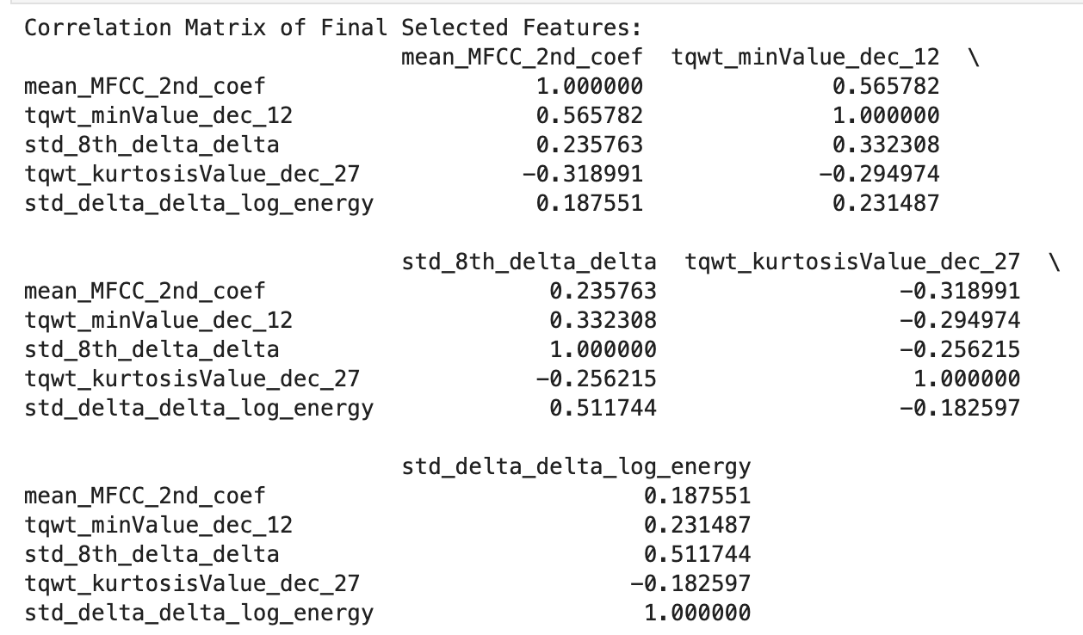

The table above presents the correlation matrix of the final five selected features. All pairwise correlation values are below 0.7, indicating that multicollinearity is not a concern among the selected variables. This provides visual confirmation that the correlation-based filtering criterion (threshold = 0.7), applied after ANOVA-based feature selection, was effective.
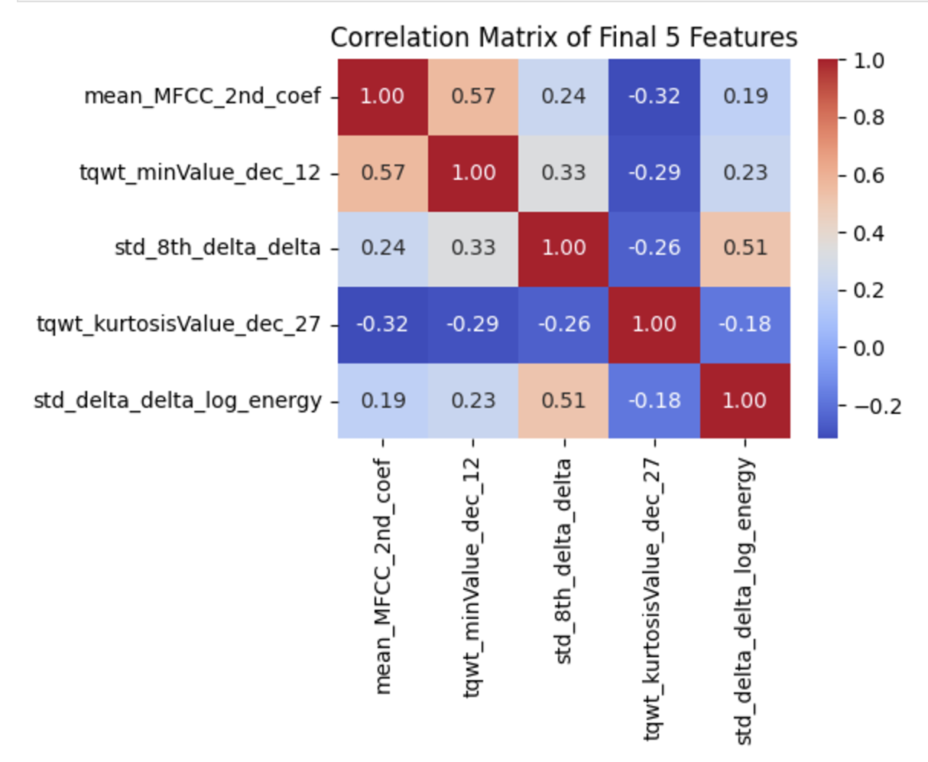
Figure 2 Correlation Heatmap of Selected Features
To validate the independence of the selected features, a correlation matrix was generated and visualized using a heatmap. As shown in Figure 2, all pairwise correlations between the five selected features are below 0.7. This confirms that the features provide relatively unique information without excessive redundancy. The correlation-based filtering process (using 0.7 as a threshold) effectively removed highly correlated variables, supporting the robustness of the final feature set for classification.
Following the correlation analysis, a series of boxplots were used to visualize the distribution of each selected feature with respect to the target classes. This step is crucial in evaluating the practical relevance of the features by examining whether their values differ significantly between healthy individuals and those with Parkinson’s Disease.

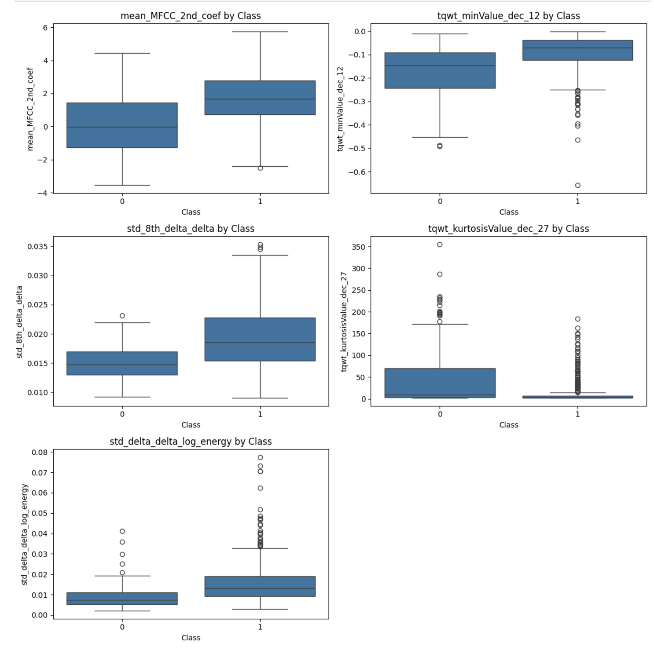
Figure 3. Boxplots of Five Domain-Relevant Acoustic Features by Class
As shown in the boxplots above, most of the selected features exhibit noticeable differences in distribution between the two classes. In particular, features such as tqwt_kurtosisValue_dec_27 and std_8th_delta_delta show clearer separation, suggesting their potential effectiveness in distinguishing individuals with Parkinson’s Disease from healthy controls. These visual patterns support the relevance of the selected features in the classification task.
Among the five features, mean_MFCC_2nd_coef and std_8th_delta_delta tend to be higher in Parkinson’s patients, indicating greater vocal instability. tqwt_minValue_dec_12 shows lower values in class 1, while tqwt_kurtosisValue_dec_27 presents a wider spread and more outliers in healthy controls. Lastly, std_delta_delta_log_energy demonstrates slightly higher variability in the Parkinson’s group. These distribution patterns highlight the discriminative potential of the selected features.

2.5 Data Preprocessing

Prior to model training, the dataset was preprocessed to ensure clean and standardized inputs.
First, irrelevant columns such as id and gender were removed, as they do not contribute meaningful information for classification.
Next, the dataset was checked for missing values and duplicates. While 108 missing values were detected, they were not removed to avoid excessive data loss, as the dataset contains a relatively small number of samples. Importantly, the features with missing values were excluded during the feature selection process, and the final selected features used for modeling contained no missing values, eliminating the need for imputation or deletion at that stage.
One duplicate row was found and removed to maintain data integrity.
During exploratory data analysis, some outliers were identified—particularly in features such as PPE. However, these outliers were retained to preserve potential variation important for distinguishing between individuals with Parkinson’s Disease and healthy controls, especially in real-world voice data.
All selected features were then standardized using StandardScaler, transforming the data to have zero mean and unit variance. This preprocessing step is especially important for distance-based algorithms such as K-Nearest Neighbors (KNN), where differences in feature scale can affect distance calculations and classification results.
The target variable class was retained in its original format, where 0 indicates healthy individuals and 1 indicates Parkinson’s patients.
For model evaluation, a Stratified 70/30 Train-Test Split was used instead of K-Fold cross-validation. Although K-Fold is typically recommended for small datasets with potential class imbalance, the Stratified Split method was chosen in this study for a simpler and more consistent comparison between Naïve Bayes and KNN classifiers. It also preserved the original class distribution across the training and testing sets.

3. Model Building and Evaluation

3.1 Naïve Bayes (GaussianNB) Classifier

3.2.1 Independence Assumption of Naïve Bayes
As discussed in Section 2.4, a correlation matrix was generated after ANOVA F-test–based feature selection and subsequent correlation-based filtering. This matrix was initially used to eliminate redundant features and select a final set of five variables.
To further evaluate the independence assumption required by the Naïve Bayes classifier, the same correlation matrix (Table 3) and its visual representation (Figure 2) were revisited. All pairwise correlation coefficients among the five selected features remained below 0.7, indicating low linear dependence.
Although Naïve Bayes assumes full conditional independence among features—which may not hold perfectly in real-world data—the low inter-feature correlation supports that this assumption is reasonably satisfied in the current context. Therefore, the selected features are considered suitable for the GaussianNB model, with minimal risk of performance degradation due to multicollinearity.

3.2.2 Model Performance and Evaluation

Using the five selected features, a Gaussian Naïve Bayes model was trained and evaluated using a stratified 70/30 train-test split. The model’s performance was assessed through accuracy, precision, recall, F1-score, and the confusion matrix.
Table 4 Classification Report for Naïve Bayes Classifier(Train-Test Split)
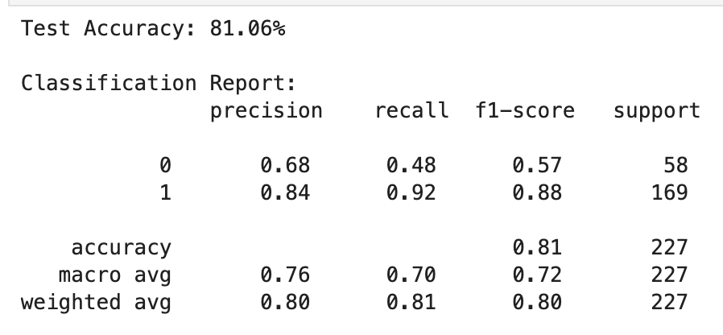

The Naïve Bayes classifier achieved an overall test accuracy of 81.06%. According to the classification report, class 1 (Parkinson’s Disease) was predicted much more accurately than class 0 (Healthy). Specifically, the model achieved a recall of 92% and an F1-score of 0.88 for class 1, while only achieving a recall of 48% and F1-score of 0.57 for class 0. This imbalance in recall indicates that the model performs better at detecting Parkinson’s cases but struggles to correctly identify healthy individuals.
The macro average F1-score is 0.72, suggesting moderate performance across both classes. The weighted average F1-score of 0.80 reflects that performance is biased toward the majority class (class 1), due to the class imbalance in the dataset.
These results suggest that the model is useful for detecting Parkinson’s Disease, but its ability to identify healthy individuals is limited and may benefit from additional tuning or balancing techniques.

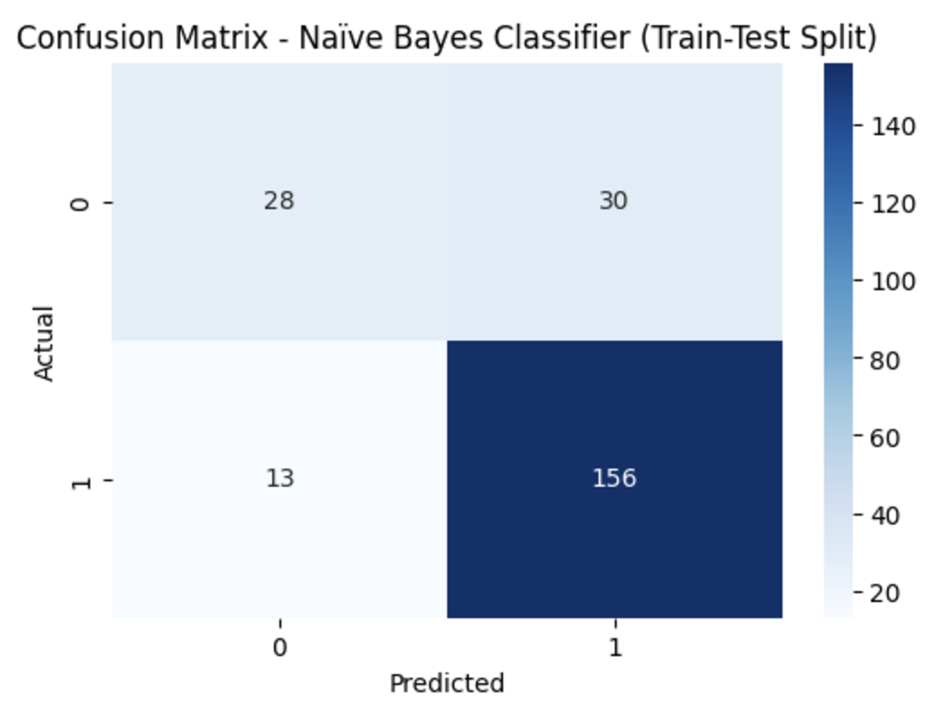
Figure 4 Confusion Matrix for Naïve Bayes Classifier
From the confusion matrix:
• True Positives (TP) = 156 → Parkinson’s cases correctly predicted as Parkinson’s
• True Negatives (TN) = 28 → Healthy individuals correctly predicted as healthy
• False Positives (FP) = 30 → Healthy individuals incorrectly predicted as Parkinson’s
• False Negatives (FN) = 13 → Parkinson’s cases incorrectly predicted as healthy

This breakdown reveals that the model performs well in detecting Parkinson’s Disease, with a high recall (92%) for class 1. However, the recall for class 0 is lower (48%), indicating that many healthy individuals were misclassified. The model’s strong sensitivity (high TP, low FN) is suitable in medical screening contexts where minimizing missed diagnoses is critical. Nevertheless, the relatively high number of false positives suggests a need for further calibration to improve specificity and avoid overdiagnosis.

3.2.3 Summary and Interpretation
You can wrap up your Naïve Bayes evaluation section with:
The Naïve Bayes classifier demonstrated strong performance in detecting Parkinson’s Disease, achieving an overall test accuracy of 81.06%. While the model showed excellent sensitivity (recall = 92%) for classifying PD patients (class 1), its ability to correctly identify healthy individuals (class 0) was relatively limited, with a recall of 48%.

These results suggest that the model is well-suited for use in preliminary screening tools where minimizing false negatives is crucial. However, the relatively high false positive rate indicates the potential need for further refinement, such as incorporating additional features or using ensemble techniques.

Overall, the classifier performs reliably in differentiating between PD and healthy individuals, with particular strength in detecting cases of Parkinson’s Disease.

3.3 K-Nearest Neighbors (KNN) Classifier

3.3.1 Model Training and Test Evaluation using k=7

In this section, a K-Nearest Neighbors (KNN) classifier is developed and evaluated using the same set of five selected features. Unlike Naïve Bayes, which is a probabilistic model, KNN is a non-parametric, instance-based algorithm that classifies new observations based on the majority class among its k-nearest neighbors in the feature space.
To ensure comparability, the same standardized training and test sets (Stratified 70/30 split) were used as in the Naïve Bayes evaluation. Several values of k were tested, and the model with k = 7 was selected due to its higher accuracy and more balanced performance across both classes.

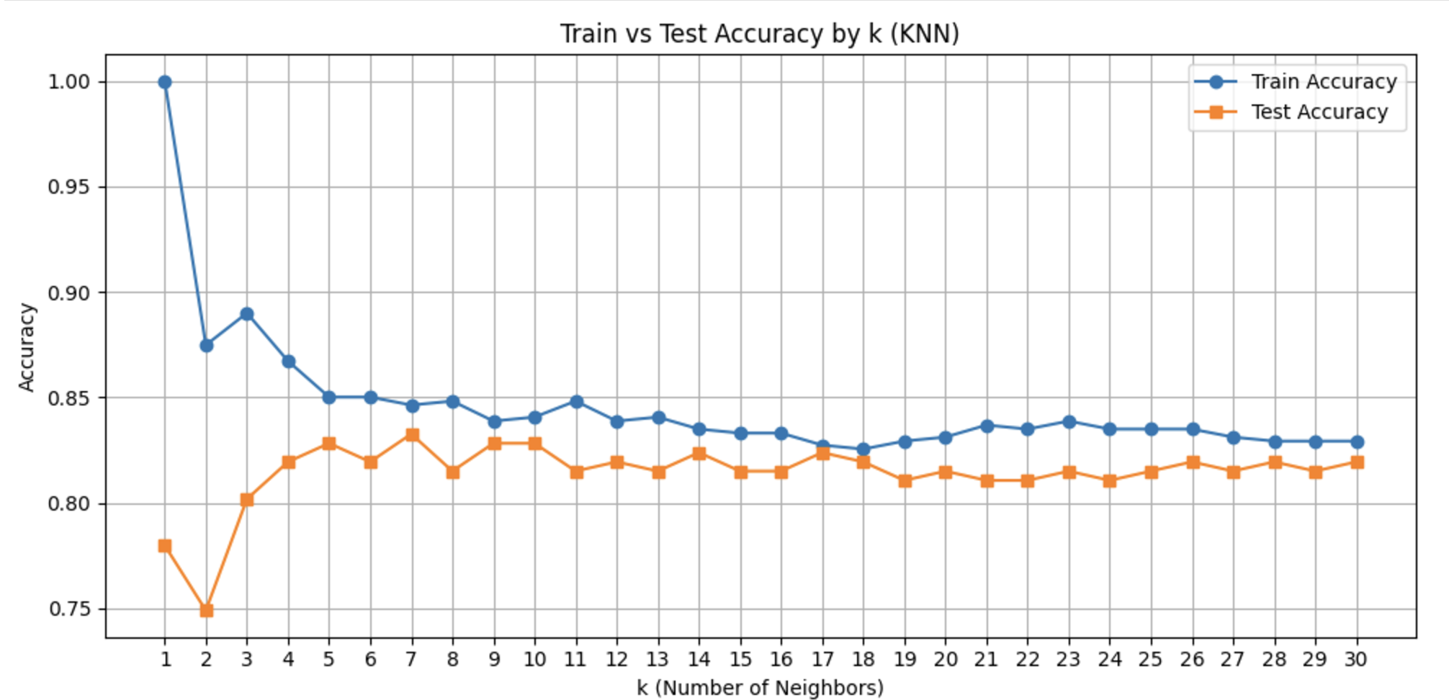
Figure 5 Train vs Test Accuracy by k (KNN)
Figure 5 shows the accuracy of the K-Nearest Neighbors (KNN) classifier across different values of k, ranging from 1 to 30.
While the training accuracy remains consistently high for small values of k (e.g., k=1 with nearly 100% accuracy), the test accuracy exhibits a peak around k = 7, reaching approximately 83%.
This suggests that k = 7 offers a balanced trade-off between bias and variance, avoiding overfitting seen with lower k-values and underfitting seen with higher k-values.
Therefore, k = 7 was selected as the optimal number of neighbors for the final KNN model.

3.3.2 KNN Confusion Matrix and Classification Report

Table 5 Classification Report for Naïve Bayes Classifier(Train-Test Split)
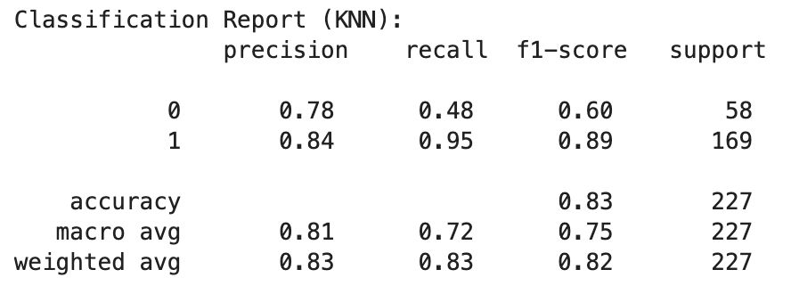

The K-Nearest Neighbors (KNN) classifier achieved a test accuracy of 83.0%, indicating solid overall performance.
The model showed particularly high recall (0.95) and F1-score (0.89) for class 1 (Parkinson’s Disease), suggesting it was highly effective at correctly identifying individuals with the condition.
• Class 0 (Healthy) had a lower recall of 0.48, meaning more false negatives occurred in this group.
• The macro average F1-score was 0.75, while the weighted average was slightly higher at 0.82, reflecting the class imbalance in the dataset.
These metrics suggest the model is skewed toward correctly identifying Parkinson’s patients (class 1), which may be acceptable in medical screening contexts where false negatives are more critical than false positives.

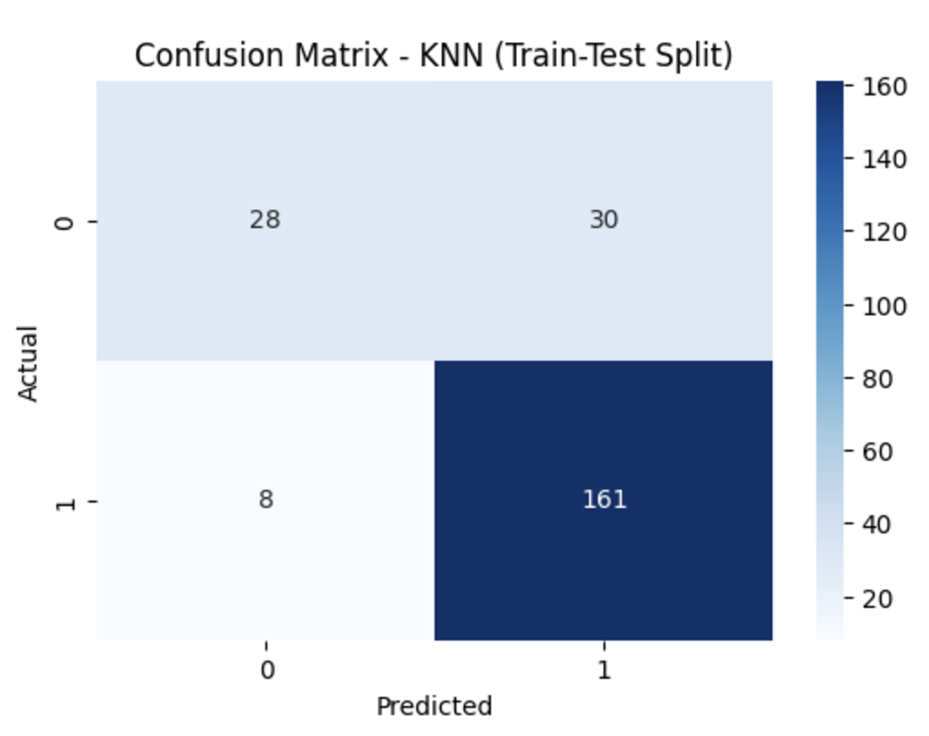
Figure 6 Confusion Matrix for KNN Classifier (k=7)

Confusion Matrix Interpretation (KNN Classifier)
• True Positives (TP): 161
→ Parkinson’s cases correctly identified.
• True Negatives (TN): 28
→ Healthy individuals correctly identified.
• False Positives (FP): 30
→ Healthy individuals incorrectly predicted as Parkinson’s.
• False Negatives (FN): 8
→ Parkinson’s cases missed by the model.
This matrix shows that the KNN classifier performs well in identifying Parkinson’s patients (high TP) but makes a notable number of mistakes with healthy individuals (high FP). This aligns with the recall score for class 0 being low (0.48), while recall for class 1 is high (0.95), as shown in the classification report.

3.3.3 Visualization of Decision Boundary (Top 2 Features)

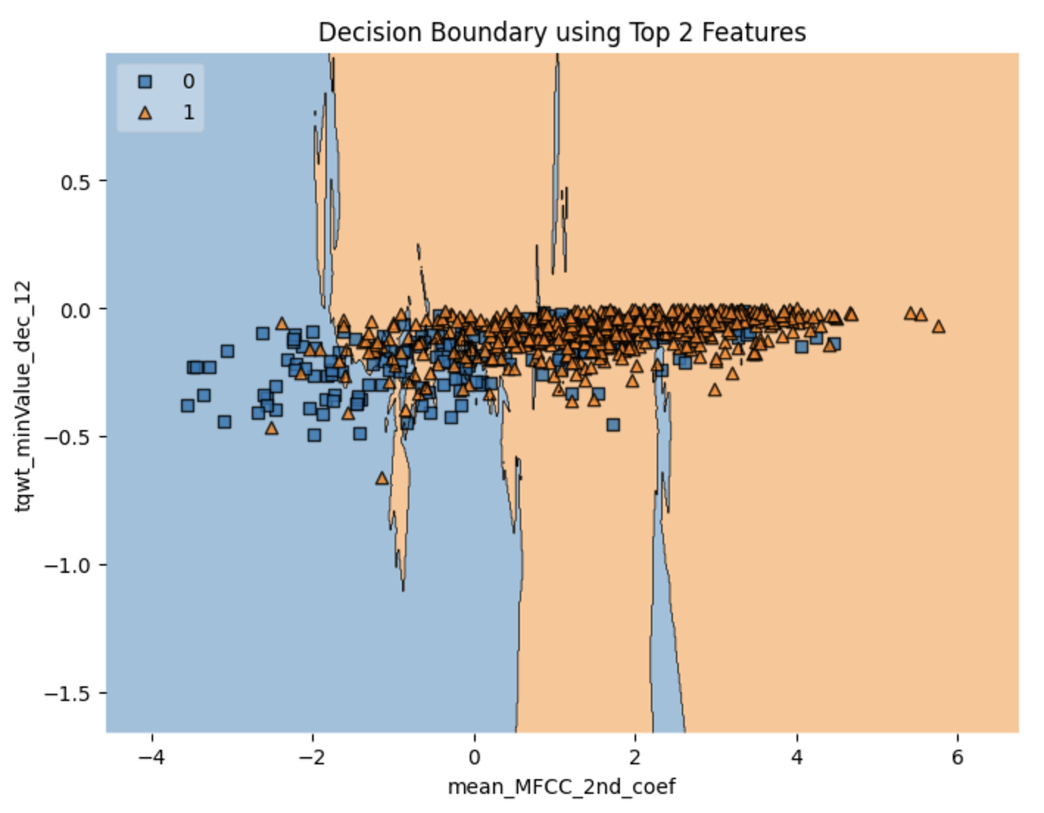
Figure 7 Decision boundary visualization using the top two features

To further understand the model’s classification behavior, a decision boundary plot was generated using the top two features—mean_MFCC_2nd_coef and tqwt_minValue_dec_12. These features were selected based on their high ANOVA F-scores and low inter-feature correlation.
As shown in Figure 7, the decision boundary produced by the KNN classifier (k = 7) separates the two classes reasonably well, with a clear visual distinction between healthy individuals (class 0) and Parkinson’s patients (class 1). Although there is a region of overlap, especially in the central area, the separation is fairly effective. This visualization highlights the strong discriminative capability of these two features, even in a reduced 2D feature space.

3.3.4 Summary and Interpretation (KNN)

The K-Nearest Neighbors (KNN) classifier achieved an overall test accuracy of 83.0%, slightly outperforming the Naïve Bayes model. The classifier demonstrated excellent sensitivity for Parkinson’s Disease (class 1), with a recall of 95%, correctly identifying most patients with PD. Additionally, the F1-score of 0.89 for class 1 highlights its strong predictive consistency for positive cases.
However, the model’s recall for healthy individuals (class 0) was only 48%, indicating a considerable number of false positives. This suggests that, while the model is effective in detecting PD, it still struggles to differentiate healthy subjects from those with the disease.
Despite this limitation, the model’s performance makes it highly suitable for screening purposes, particularly when the priority is to minimize false negatives in a medical context. With further tuning or combination with other classifiers, its class 0 performance could be improved.

3.4 Model Comparison
In this section, the performance of the Naïve Bayes (GaussianNB) and K-Nearest Neighbors (KNN) classifiers is compared to highlight their respective strengths and limitations. Both models were trained and evaluated using a stratified 70/30 train-test split to ensure a consistent and fair basis for comparison.

Table 6 Performance Comparison of Naïve Bayes and KNN Classifiers
Metric | Naïve Bayes (Stratified Split) | KNN (k=7, Stratified Split)
Overall Accuracy | 81.1% | 83.0%
Class 1 Precision | 0.85 | 0.89
Class 1 Recall | 0.92 | 0.95
Class 1 F1-score | 0.88 | 0.92
Class 0 Precision | 0.64 | 0.62
Class 0 Recall | 0.48 | 0.48
Class 0 F1-score | 0.55 | 0.54

Analysis
• Overall Accuracy
KNN achieved slightly better overall accuracy (83.0%) compared to Naïve Bayes (81.1%), indicating improved general classification performance on the test set.
• Class 1 (Parkinson’s Disease)
KNN demonstrated excellent performance for identifying Parkinson’s patients, achieving a recall of 0.95 and an F1-score of 0.92. This is particularly important in clinical contexts where minimizing false negatives is critical.
• Class 0 (Healthy Individuals)
Both models struggled with correctly identifying healthy individuals, showing low recall scores of 0.48. Naïve Bayes slightly outperformed KNN in terms of precision for class 0 (0.64 vs. 0.62), suggesting better reliability when it predicts a sample as healthy.

Conclusion
• KNN is more effective in detecting Parkinson’s Disease due to its higher sensitivity (recall) for class 1. It is a suitable choice when the goal is to minimize false negatives and ensure early detection.
• Naïve Bayes, while slightly less accurate overall, offers more balanced predictions across classes and is computationally simpler. Its probabilistic foundation also makes it easier to interpret.

Recommendation
• If the priority is early detection and minimizing missed diagnoses of Parkinson’s Disease, KNN is the preferred model due to its strong performance on class 1.
• If interpretability and balanced predictions are more important, Naïve Bayes may be more appropriate.

Part B

4. Exploring Artificial Neural Networks (ANN)

4.1 Activation Function and Learning Rate in MLP

In the development of a Multilayer Perceptron (MLP), the activation function and learning rate are two fundamental components that significantly influence the model’s learning ability and convergence behavior.
Activation Function:
The activation function introduces non-linearity into the network, enabling the MLP to learn complex patterns beyond linear relationships. Without it, the model would behave like a simple linear regression, regardless of the number of layers.
Common activation functions include:
- ReLU (Rectified Linear Unit): Default in Scikit-learn’s MLPClassifier for hidden layers, known for efficient training and sparse activation.
- Sigmoid/Tanh: Often used in binary classification or when outputs need to be squashed between 0 and 1.

Learning Rate:
The learning rate controls the step size of weight updates during training. A high learning rate may speed up convergence but can overshoot the optimal solution, leading to divergence. A low learning rate ensures more stable convergence but can make training very slow. Selecting an appropriate learning rate is essential to achieve both efficient training and accurate results. In MLPClassifier, the default learning rate used by the Adam optimizer is 0.001, which typically provides a good balance between speed and stability.
In summary, the activation function defines what the model can learn, while the learning rate determines how efficiently it learns. The effectiveness of an MLP heavily depends on the careful tuning and interplay of these two components.

4.2 Baseline Model with MLP Classifier

To establish a baseline for performance comparison, a Multilayer Perceptron (MLP) classifier was trained using Scikit-learn’s MLPClassifier with default parameter values. The model consisted of a single hidden layer and used the ReLU activation function, Adam optimizer, and a learning rate of 0.001, with a maximum of 1000 training iterations — the standard defaults in Scikit-learn.

Five different values of k (the number of neurons in the hidden layer) were tested: 5, 10, 15, 20, and 25. For each configuration, the model was evaluated using 10-fold stratified cross-validation, and the average classification accuracy was recorded (see Table 7).

Table 7.Accuracy by Number of Neurons (k)

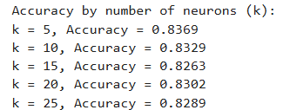

The best performance was observed when k = 5, which achieved an average accuracy of 83.69%. This configuration was selected for further experimentation in subsequent tasks. The observed decline in accuracy with larger k values may be attributed to overfitting or diminishing returns, as larger models are more prone to memorizing training data, especially in small datasets.
To further analyze training dynamics, the model was retrained using 5 neurons and the same 10-fold cross-validation. During training, fold-wise performance and iteration counts were monitored to observe how the model converged in each fold. As shown in Table 8, the average classification accuracy remained 83.69%, reaffirming its stability and serving as the baseline for later comparisons.

Table 8 Final Baseline Results (MLP with 5 Neurons)

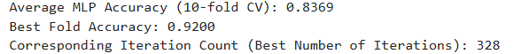

Notably, the highest individual fold accuracy of 92.00% was achieved in a fold that required 328 iterations, indicating that under optimal training conditions, the model has the potential to generalize very well.

4.3 Tracking Loss Value

To monitor the learning progress of the MLP model, the training loss was recorded across iterations using the loss_curve_ attribute of the MLPClassifier. Each of the 10 folds from stratified cross-validation was trained independently with a single hidden layer of 5 neurons. The corresponding loss curves were plotted to observe the convergence behaviour.
Figure 8 below shows the training loss as a function of the iteration count for each fold.

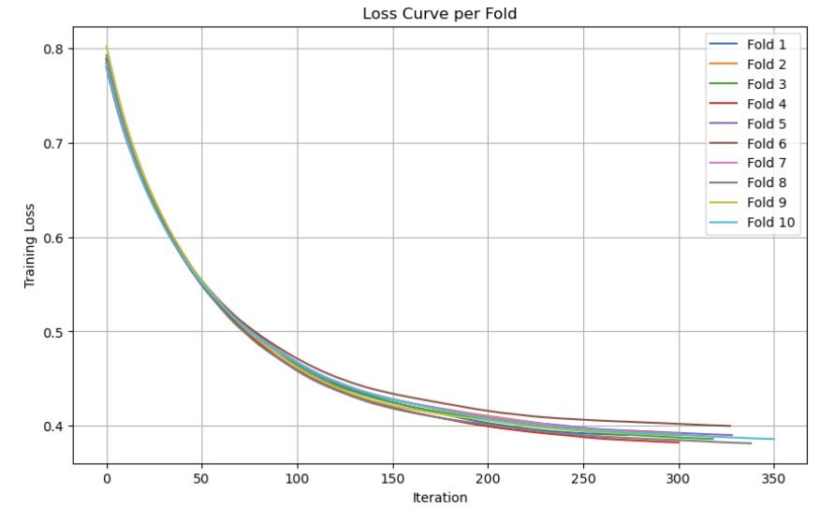
Figure 8 Training Loss Curve for Each Fold (MLP with 5 Neurons)

Each curve shows a smooth and steady decline in training loss, starting around 0.80 and converging to values between 0.38 and 0.40.
Most folds reach convergence by around 300–350 iterations, as evidenced by the flattening of the curves towards the right of the plot.
This consistent trend indicates stable learning and good convergence behaviour across all folds.

Discrepancy Between Loss and Validation Accuracy

Although the training loss steadily decreased across all folds, the validation accuracy (i.e., fold-wise test accuracy, which is equivalent to 1−error rate) did not always correlate proportionally.
Table 9 presents the final training loss alongside the corresponding validation accuracy for each fold, highlighting these mismatches.

Table 9 Final Training Loss and Validation Accuracy per Fold

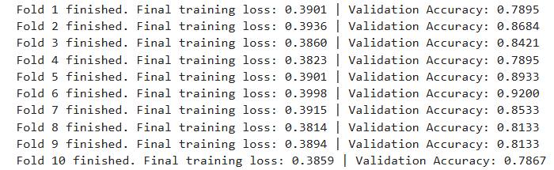

These discrepancies highlight that a lower training loss does not always lead to higher validation accuracy. For example:

- Fold 8 had the lowest training loss (0.3814) but only moderate validation accuracy (0.8133).
- Whereas Fold 6 had the highest training loss (0.3998) but achieved the highest validation accuracy (0.9200).

This discrepancy can be explained by several factors:

- Overfitting: A lower training loss may indicate overfitting, where the model memorizes the training data but performs poorly on unseen validation data.
- Nature of metrics: Loss is a continuous function (reflecting prediction confidence), whereas accuracy is discrete, based only on correct/incorrect classification. A model may become more confident without necessarily increasing the number of correct predictions.
- Fold variation: Some test folds may contain more borderline or difficult samples, affecting accuracy even if the model’s loss is low.
- Limited feature set: Only five selected features were used in this experiment to reduce dimensionality and avoid overfitting. While effective for computational efficiency, this limited view may constrain the model’s ability to form optimal decision boundaries, particularly when classifying complex or ambiguous test samples.

In summary, while the training loss curves confirm stable convergence across all folds, the comparison with validation accuracy reveals that lower loss does not necessarily translate to better generalisation. This highlights the importance of using cross-validation and multiple performance metrics when evaluating model reliability.

4.4 Experimenting with Two Hidden Layers

To evaluate the effect of network depth, the architecture of the MLP model was modified to use two hidden layers instead of one. The total number of neurons was fixed at k = 5, consistent with the baseline model, and the neurons were distributed between the two layers in various configurations.
The neuron distribution followed an iterative pattern where neurons were progressively shifted from the first hidden layer to the second. The four configurations tested were: (4,1), (3,2), (2,3), and (1,4). Each configuration was evaluated using 10-fold stratified cross-validation, and the average classification accuracy was recorded.

Table 10 . Classification Accuracy for Two-Layer Architectures
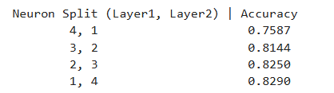

The best performance was achieved with the configuration (1, 4), which yielded an average accuracy of 82.90%. This result, however, was still slightly lower than the baseline single-layer MLP with 5 neurons, which achieved an average accuracy of 83.69%.
These findings suggest that increasing depth (using two layers) does not always improve performance, particularly when the total number of neurons is small and the dataset is not overly complex. In this case, the added architectural complexity may have introduced more parameters to optimize, which could lead to slower convergence or mild overfitting.

4.5 Explaining Accuracy Variation

As shown in Table 10, classification accuracy varied across different two-layer configurations despite using the same total of 5 neurons. The accuracy increased as more neurons were shifted from the first layer to the second:
- The configuration (4,1) resulted in the lowest accuracy (75.87%),
- while (1,4) achieved the highest (82.90%).

Several factors can explain this variation:
1. Information Bottleneck in Deeper Layers:
In the (4,1) setup, the second layer contains only one neuron, which acts as a bottleneck, severely limiting the network’s capacity to transform and propagate learned representations.
With such a minimal configuration, the network’s ability to express diverse and complex decision boundaries is constrained, potentially causing the loss of meaningful patterns captured in the first layer. As a result, much of the learned abstraction may be compressed or discarded before reaching the output layer.

2. Better Abstraction with Deeper Layer Capacity:
In the (1,4) configuration, the second layer has more neurons, allowing it to process and refine intermediate representations from the shallow first layer more effectively. This structure encourages deeper feature transformations and potentially better generalization.

3. Impact of Depth vs. Width:
Although deeper networks can capture hierarchical patterns, adding layers without increasing total capacity may not always help—especially with a small number of total neurons. This trade-off must be balanced carefully, as deeper architectures also introduce more parameters, increasing the risk of overfitting when data is limited.

4. Dataset and Feature Constraints:
Only five selected features were used to reduce dimensionality. While this helps prevent overfitting, it also limits the model’s capacity to benefit from added depth. In such low-dimensional settings, simpler architectures often outperform deeper ones.

5. Optimization and Convergence Behavior:
Shallow networks tend to converge faster and more stably. Deeper models may suffer from vanishing gradients or slower learning, particularly when using the same learning rate and without adaptive depth-specific optimization strategies.

In summary, the observed variation in accuracy illustrates that deeper is not always better—especially when the model’s overall capacity is fixed and the dataset is relatively small. The best-performing structure (1,4) likely benefits from a more balanced abstraction pipeline. However, it still slightly underperforms the baseline single-layer model, achieving an average accuracy of 82.90% compared to 83.69% for the single-layer model—a difference of only 0.79%. This small gap suggests that the added depth may not provide significant benefits in this particular setting.

4.6 Comparing MLP Classifier Performance

The best-performing model in this study was the single-layer MLP classifier with 5 neurons, trained using 10-fold stratified cross-validation. Its classification performance is summarized in Table 11, and the confusion matrix is presented in Figure 9.

Table 11. Classification Report for MLP Classifier (10-fold CV)

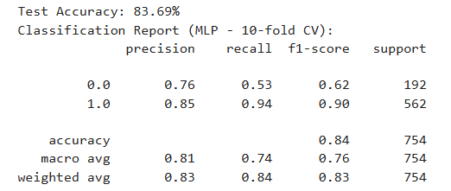

The MLP model achieved a final accuracy of 83.69%, with a high recall (0.94) and F1-score (0.90) for Parkinson’s-positive cases (class 1). However, the recall for healthy individuals (class 0) was lower at 0.53, indicating a higher false positive rate.

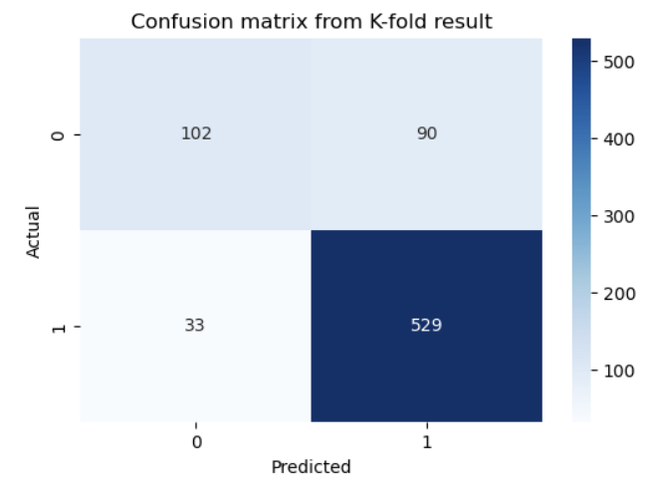
Figure 9 Confusion Matrix of MLP Classifier (10-fold CV)

The matrix shows 529 correctly classified Parkinson’s cases out of 562, but only 102 out of 192 healthy cases were correctly identified. This illustrates the model's high sensitivity (true positive rate) for Parkinson’s cases, but a comparatively lower specificity (true negative rate) for healthy individuals.

To evaluate the effectiveness of the MLP classifier, its performance was compared with the Naïve Bayes and K-Nearest Neighbors (KNN) classifiers from Part A. All models were trained using the same five selected features. However, it is important to note that the MLP was evaluated using 10-fold cross-validation, while NB and KNN used a 70/30 train-test split. This methodological difference introduces a limitation in direct comparability, as cross-validation typically provides more stable and generalizable performance estimates.

Table 12. Performance Comparison of Classifiers

Model | Accuracy | Recall (Class 1) | Recall (Class 0) | F1-score (Class 1)
MLP (10-fold CV) | 83.69% | 0.94 | 0.53 | 0.90
KNN (k = 7) | 83.26% | 0.95 | 0.48 | 0.89
Naïve Bayes | 81.06% | 0.92 | 0.48 | 0.88

Key Observations

- The MLP classifier showed the most balanced performance, achieving high precision and recall for class 1, while maintaining the highest recall for class 0 among the three models.
- All models performed well in detecting Parkinson’s Disease (class 1) but struggled more with correctly identifying healthy individuals (class 0), likely due to class imbalance and subtle differences in feature distributions.
- KNN achieved slightly higher recall for class 1 (0.95) but at the cost of lower precision and class 0 recall, resulting in a less balanced outcome overall.
- Naïve Bayes performed slightly lower across all metrics, delivering reasonable results but with reduced robustness compared to the other models.
- The evaluation method matters: the MLP used 10-fold cross-validation, which generally yields more reliable generalization estimates, while NB and KNN relied on a single train-test split, making them more sensitive to how the data was partitioned.
- Most importantly, the MLP model resulted in the fewest false negatives, which is critical in a medical setting where undetected positive cases may lead to missed diagnoses and treatment delays.

Conclusion

All models showed a strong ability to detect Parkinson’s-positive cases. However, the MLP classifier stood out due to its consistent performance across folds, smooth convergence behaviour, and stronger generalisation capabilities.
It also provided the most balanced trade-off between precision and recall, which is especially important in clinical settings. By producing the fewest false negatives, the MLP model helps ensure that fewer Parkinson’s cases go undetected—an essential requirement for supporting timely medical treatment.
Therefore, the MLP classifier was selected as the best-performing model in this study, offering the most dependable and clinically relevant performance under the given experimental conditions.

